**Assignment sheet for IAM Assignment**

1. ***Create an IAM user with username of your own wish and grant administrator policy***

* Create user name with **Batman**

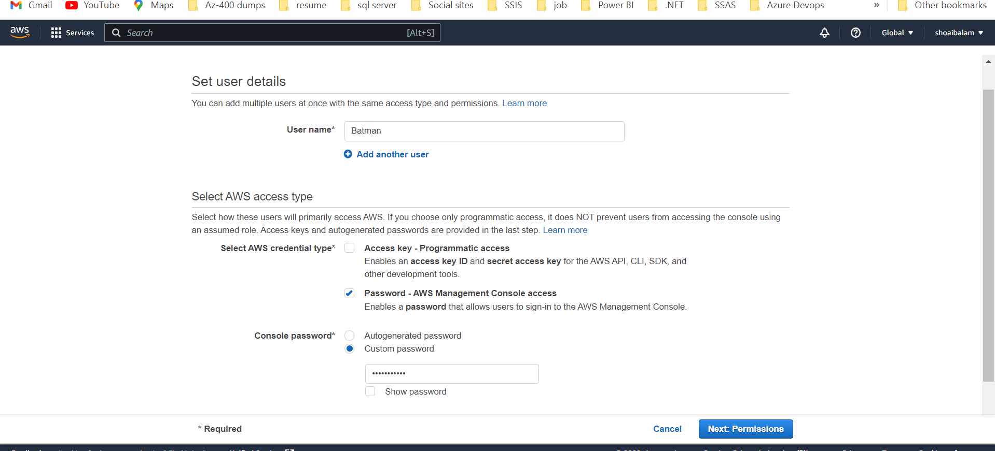

* 1. Created a group **Shoaib_IBM** and **grant** administrator policy

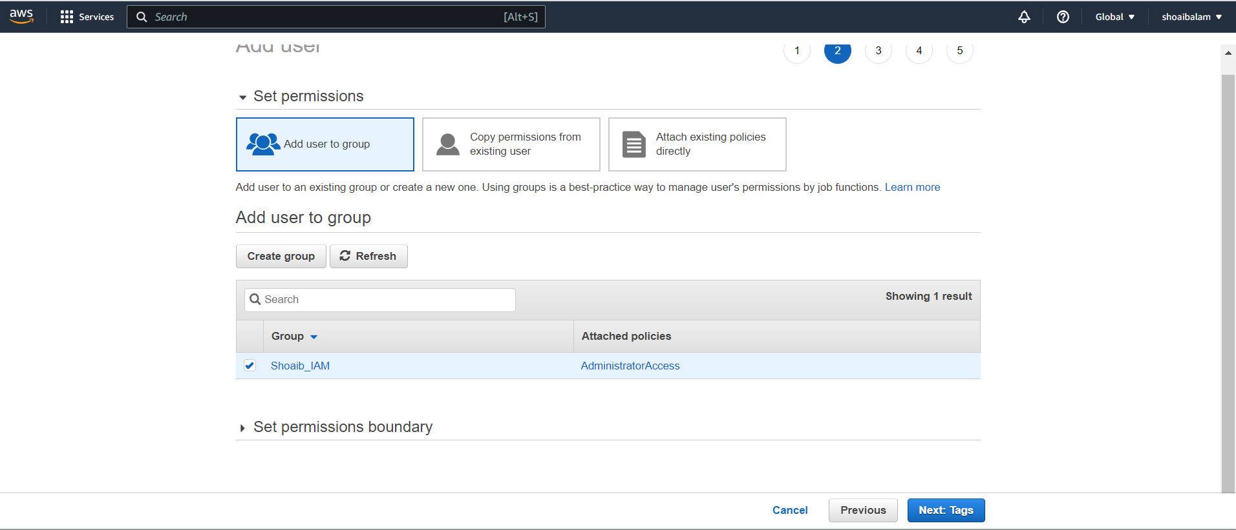

* Click on create user and user is created

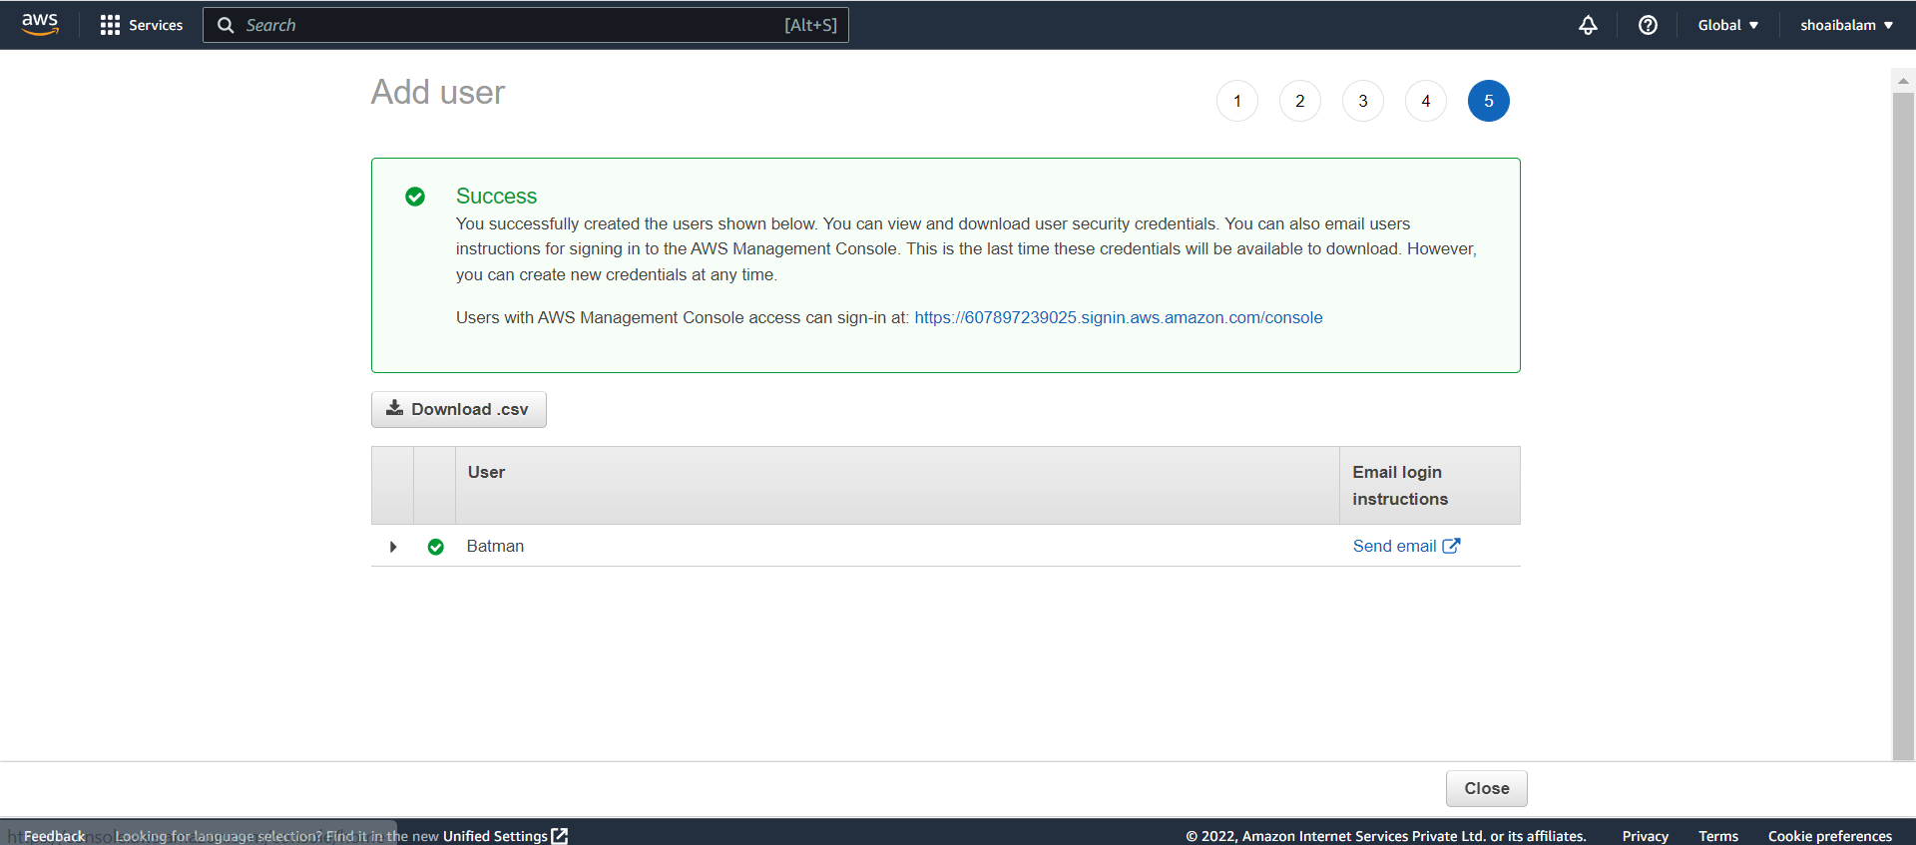

1. ***Hello students, in this assignment you need to prepare a developers team of avengers. - Create 3 IAM users of avengers and assign them in developer’s groups with IAM policy.***

* Add 3 user name using add username button

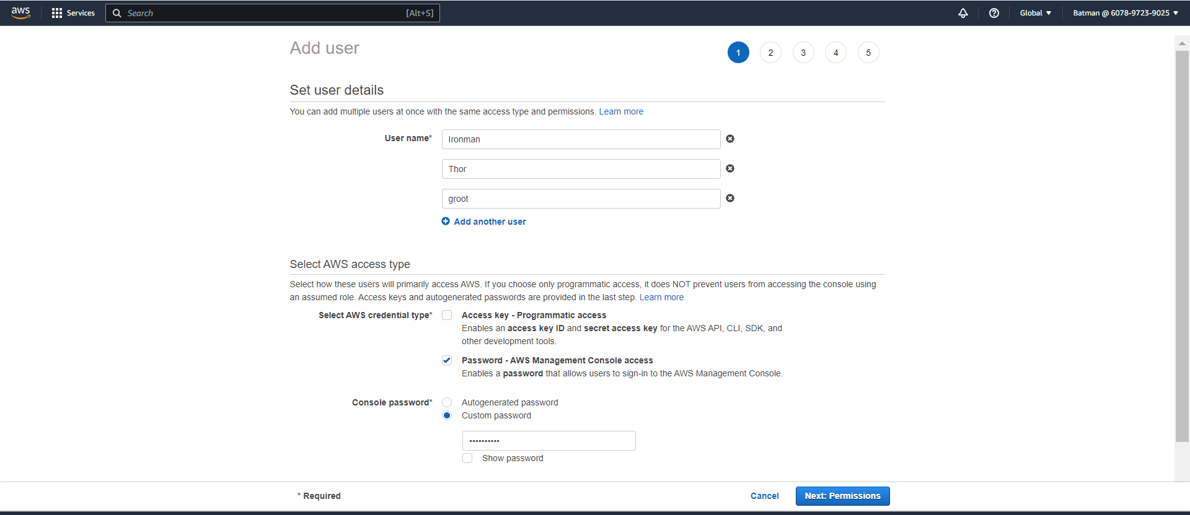

* Create a group name **developer** and add IAM Policy .

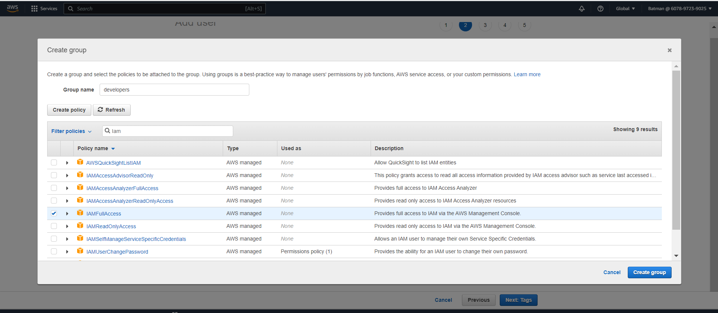

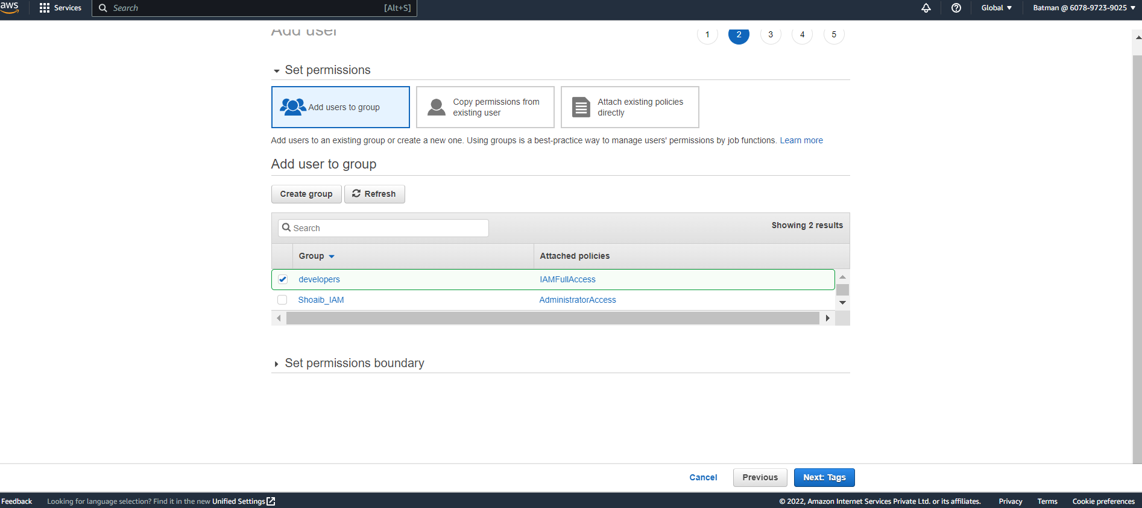

* Check the user created in the User tab at the right side of the console

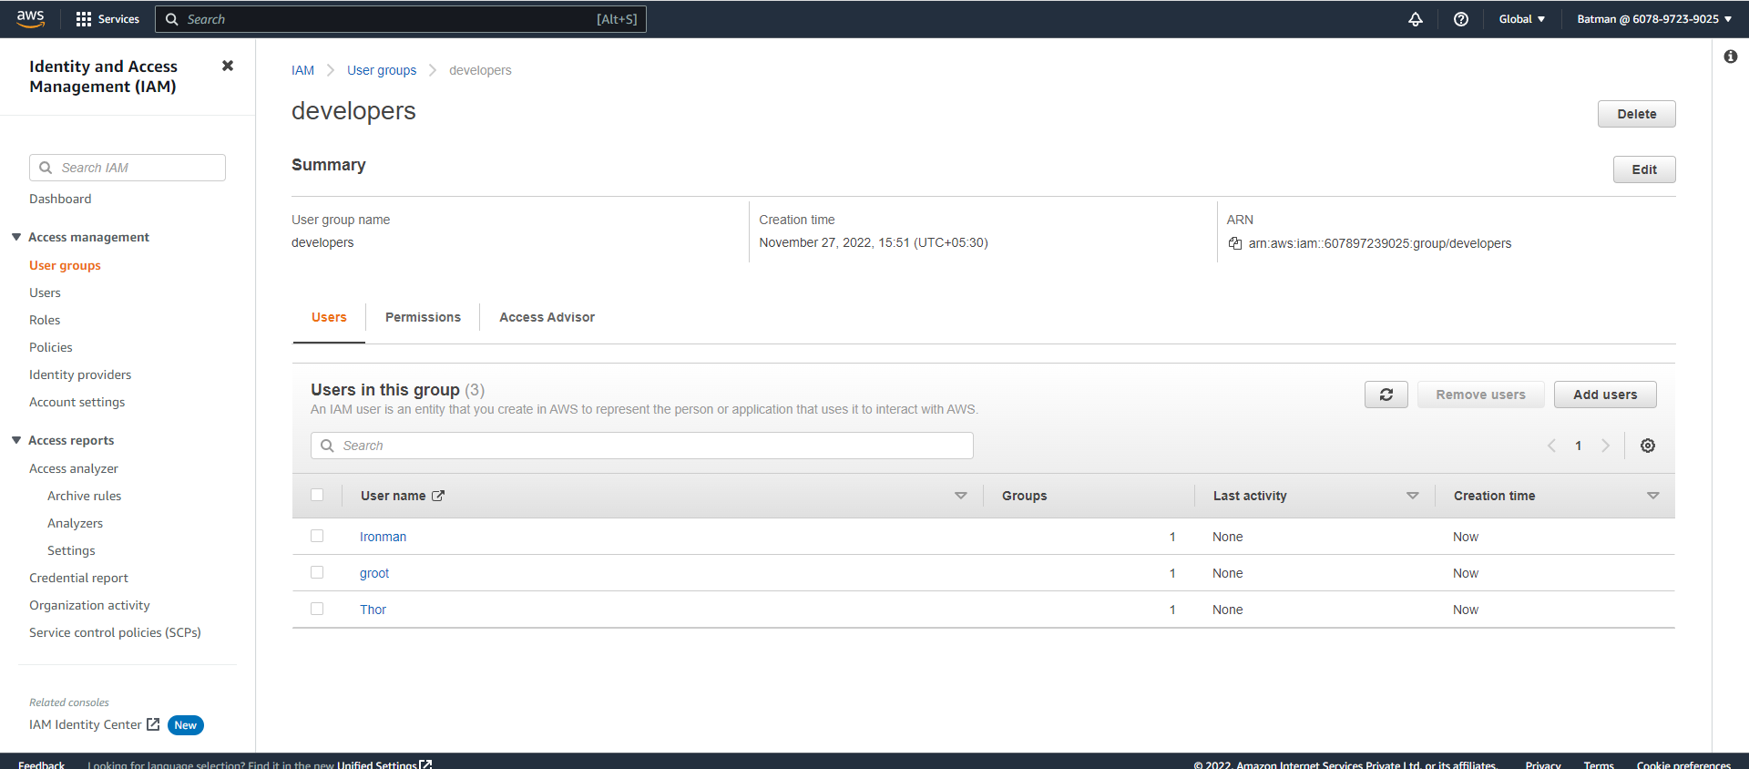

1. ***Define a condition in policy for expiration like***

"DateGreaterThan": {"aws:CurrentTime": "2020-04-01T00:00:00Z"}, "DateLessThan": {"aws:CurrentTime": "2020-06-30T23:59:59Z"}

* Created new policy for expiration

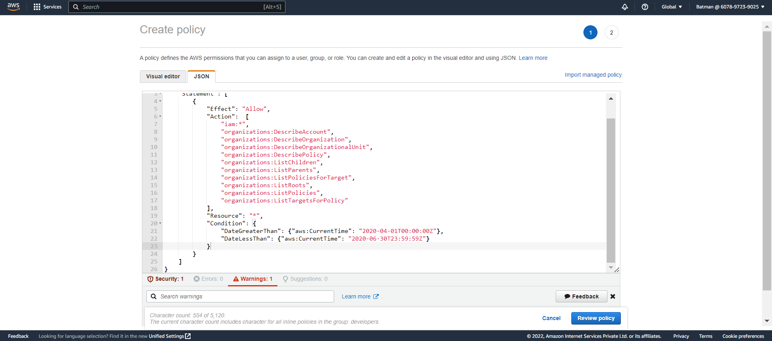

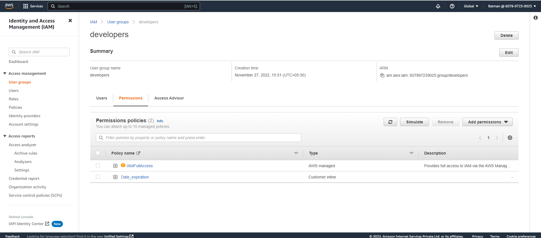

1. ***Prepare 15 authentic MCQ questions related to IAM.***
   1. IAM policy documents are written in which format? **JSON**
   2. Which user has no permission by default? **IAM user**
   3. One of the elements is an optional element of an IAM policy document, which one is it? **Condition**
   4. What you need to allow a lambda function to do an action on S3 Bucket**?  IAM Role and IAM Policy**
   5. This IAM resource can be reused across multiple identities, guess who? **IAM Managed Policies**
   6. What are managed by using IAM? **MFA, Role**
   7. What is the name of the tool which tells if identities within your account would be able to take actions? **The Policy Simulator**
   8. Which of these are features of IAM?  **Access Advisor, Password policy**
   9. This is not a component of IAM?  Organizational Units
   10. This is not a feature of IAM**? IAM allows you to setup biometric authentication, so that no passwords are required**
   11. describes IAM**?  IAM allows you to manage users, groups, roles, and their corresponding level of access to the AWS Platform**.
   12. IAM principal? User, role and application
   13. IAM roleDoes not have any credentials (password or access keys) associated with it
   14. AWS evaluates _______ when an IAM principal makes a request.? **Security Policies**
   15. Names of IAM identities (users, roles, and groups)? **Must be unique within the AWS account**
2. ***-Launch your linux instance in IAM and update your machine***
   1. Linux instance created

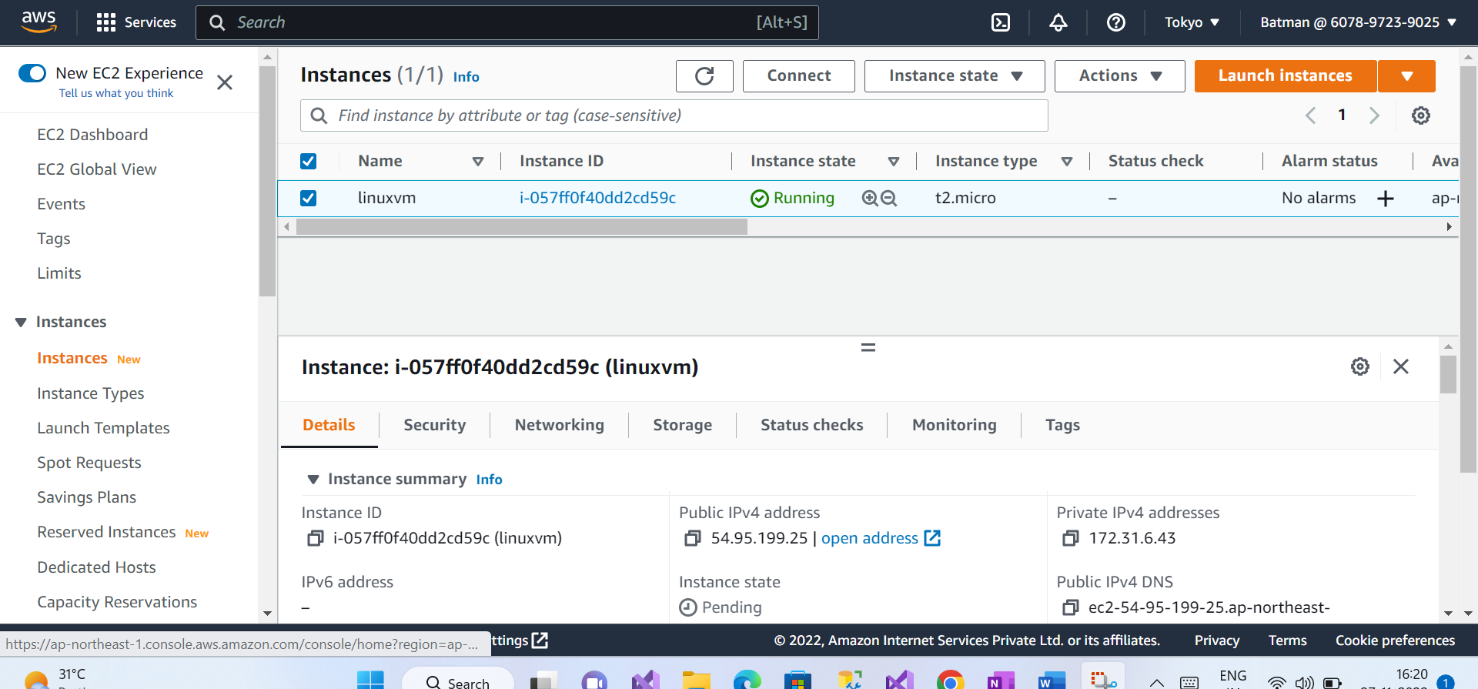

* Update the system

